深 圳 大 学

实 验 报 告

课程名称： 数据库系统

实验序号： 实验2

实验名称： SQL的多表连接查询以及视图

学 号： 2022150083

姓 名： 江浩

实验完成日期： 2024 年 10 月 17 日

一、实验目的：
- 了解DBMS系统的功能、软件组成；
2、掌握利用SQL语句定义、和简单操纵数据库的方法。

二、实验要求：
1、在课外安装相关软件并浏览软件自带的帮助文件和功能菜单，了解DBMS的功能、结构；
2、创建一个有两个关系表的数据库；（建议采用PostgreSQL）
3、数据库、关系表定义；
4、学习定义关系表的约束(主键、外键、自定义)；
5、学习SQL复杂的单表查询；
6、了解SQL多表连接查询
8、了解视图的概念；

三、实验设备：
计算机、数据库管理系统如PostgreSQL，pgAdmin4等软件。

四、实验内容
1、完成实验指导书的EX3-7以下题号.（要有题目语句和运行结果截屏）
Exercises3第7,8题
7 List the average salary of employees that receive a salary, the average commission of employees that receive a commission, the average salary plus commission of only those employees that receive a commission and the average salary plus commission of all employees including those that do not receive a commission. (single statement)
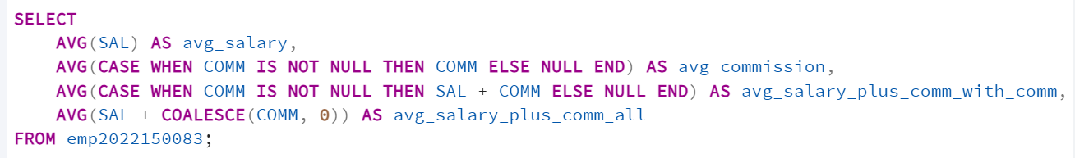
8 Compute the daily and hourly salary for employees in department 30, round to the nearest penny. Assume there are 22 working days in a month and 8 working hours in a day.
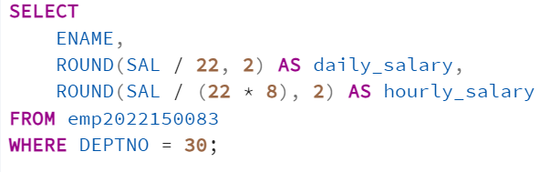
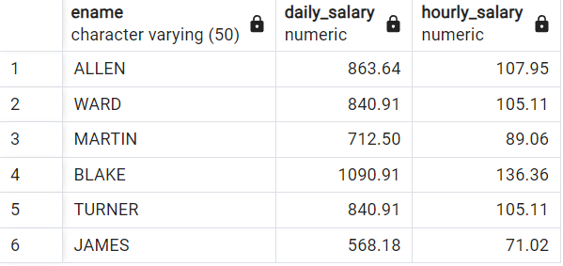

Exercises4第3,6,7,8题

3.Which employees were hired in April?
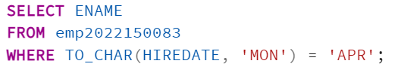
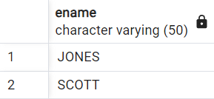
6 Show the weekday of the first day of the month in which each employee was hired. (plus their names)
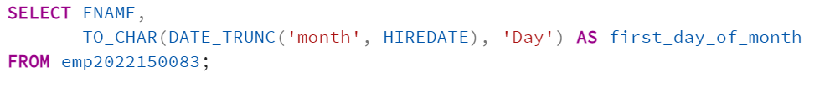
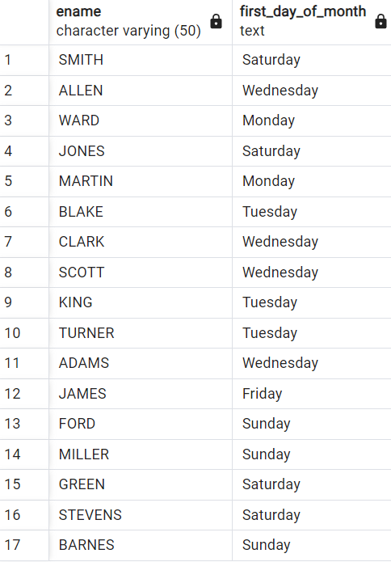
7 Show details of employee hiredates and the date of their first payday. (Paydays occur on the last Friday of each month) (plus their names)
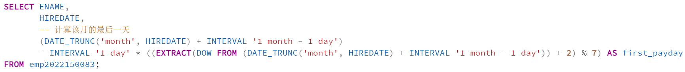
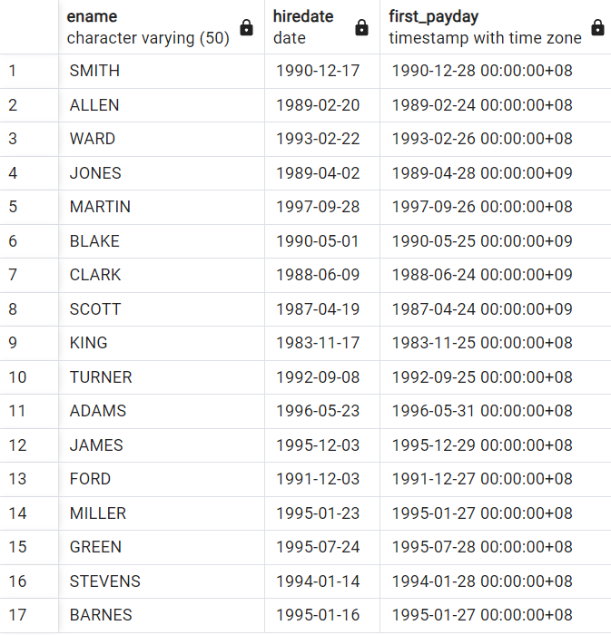
8 Refine your answer to 7 such that it works even if an employee is hired after the last Friday of the month (cf Martin)
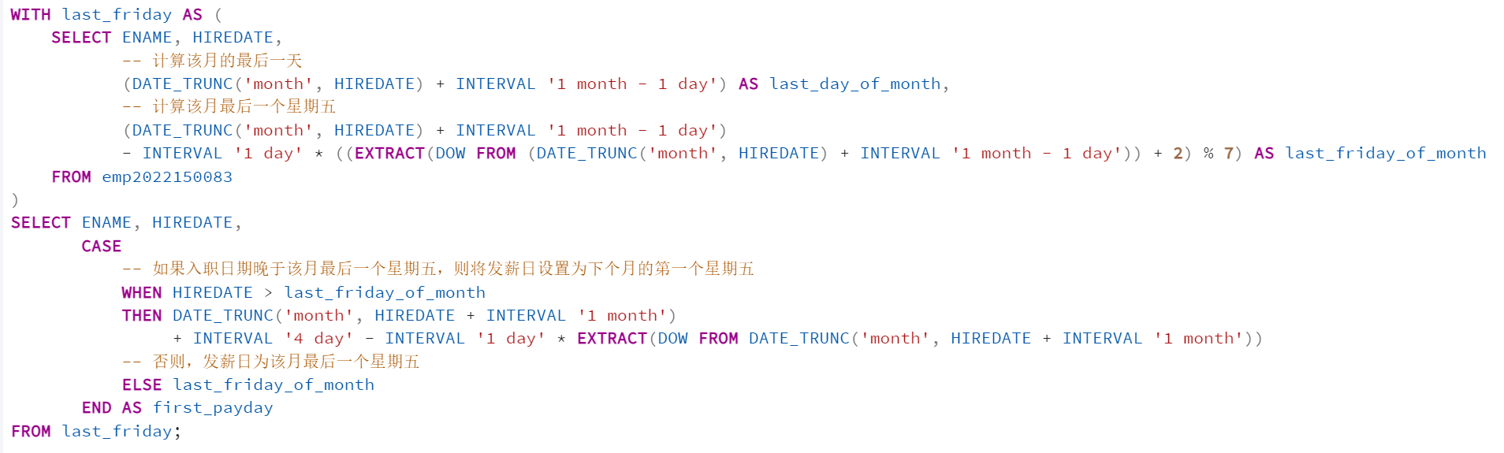
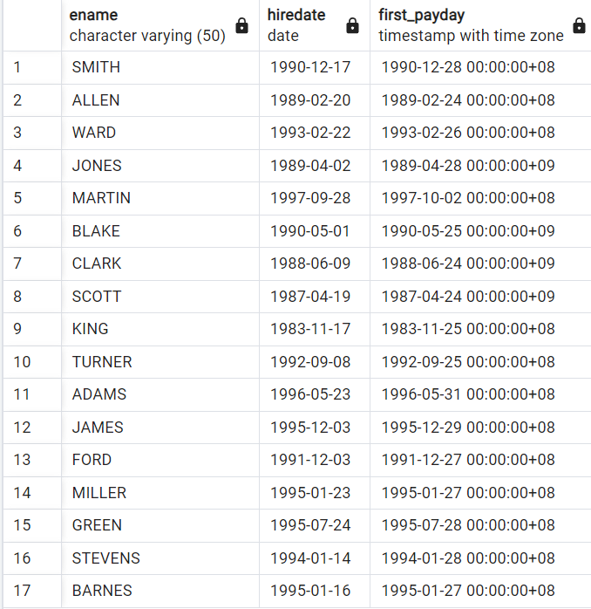
Exercises,5第2,6题
2 Divide all employees into groups by department and by job within department. Count the employees in each group and compute each group's average annual salary.
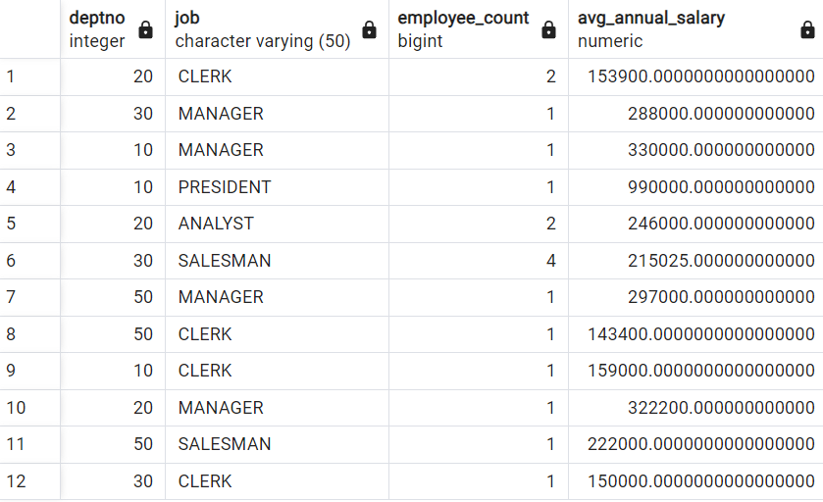
6 Find each department's average annual salary for all its employees except the managers and the president.
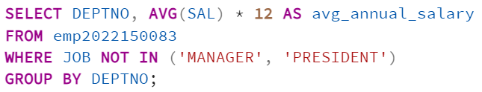
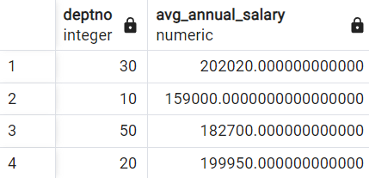
Exercises6第2,4,5,6,7题
2 Find all the employees in Department 10 that have a job that is the same as anyone in department 30.
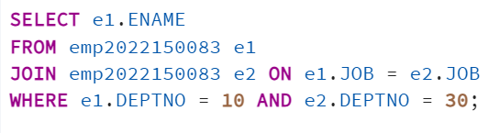
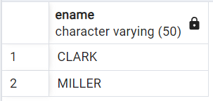
4 Find all employees in department 10 that have a job that is the same as anyone in the Sales department
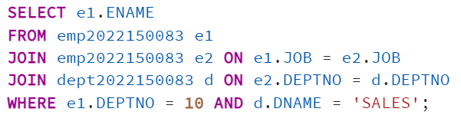
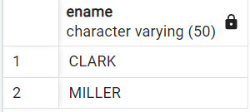

5 Find the employees located in Liverpool who have the same job as Allen.Return the results in alphabetical order by employee name.
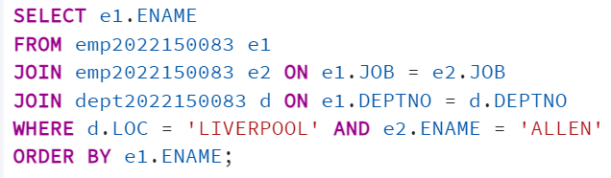
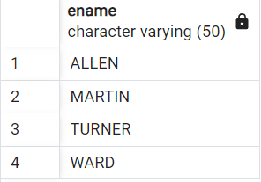

6 Find all the employees that earn more than the average salary of employees in their department.
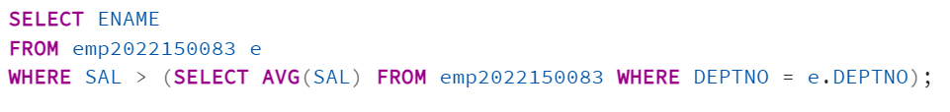
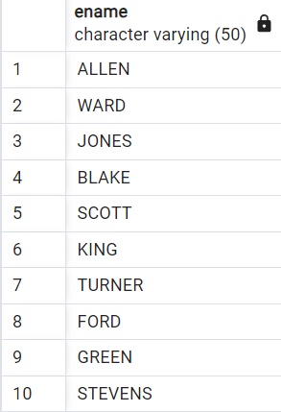

7 Find all the employees that earn more than JONES, using temporary labels to abbreviate table names.
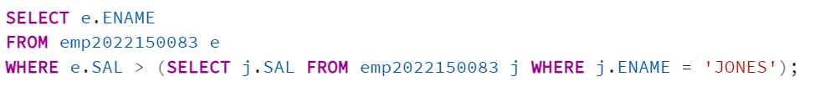
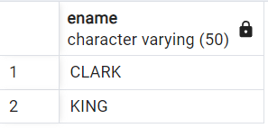
Exercises7第1,2,5,7,8,9题
1 Create a new table called loans with columns named LNO NUMERIC (3), EMPNO NUMERIC (4), TYPE CHAR(1), AMNT NUMERIC (8,2)
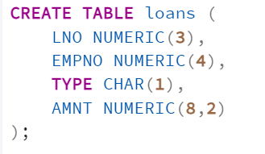
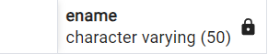
2 Insert the following data

LNO EMPNO TYPE AMNT
23 7499 M 20000.00
42 7499 C 2000.00
65 7844 M 3564.00
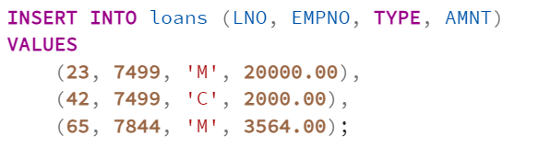
5 Add 10% interest to all M type loans
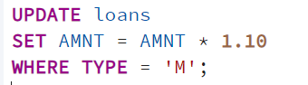
7 Change the name of loans table to accounts
8 Change the name of column LNO to LOANNO
9 Create a view for use by personnel in department 30 showing employee name, number, job and hiredate
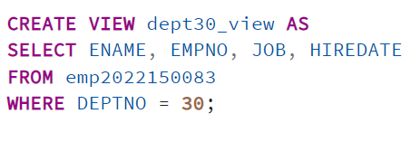
附加题：
1.陈老师想要查询学生学号，学生姓名，答题的课程序号，答题的开始时间，并按课程序号由小到大排序显示
SELECT students.stu_id, students.stu_name, exercise.lect, exercise.startTime
FROM students
JOIN exercise ON students.stu_name = exercise.stu_name
ORDER BY exercise.lect ASC;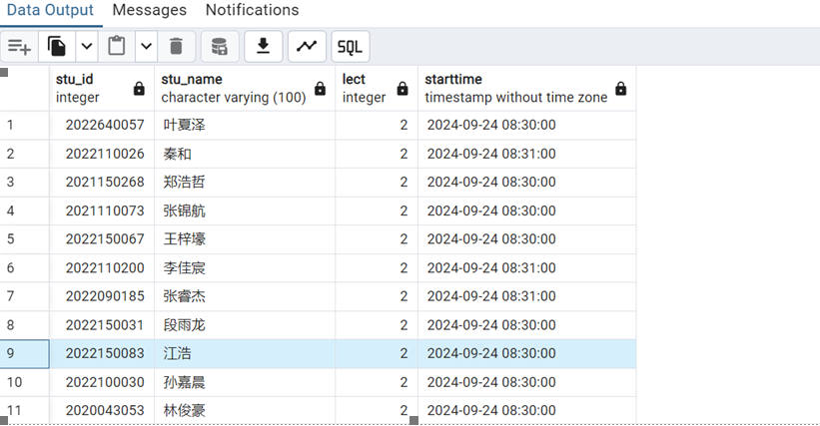
2.陈老师想要根据你本人的姓名查询你的学号，专业，每次答题的课程序号、所花费时间以及答题所用字数。SELECT students.stu_id, students.major, exercise.lect, exercise.duration,
LENGTH(exercise.q1) + LENGTH(exercise.q2) AS total_characters
FROM students
JOIN exercise ON students.stu_name = exercise.stu_name
WHERE students.stu_name = '江浩';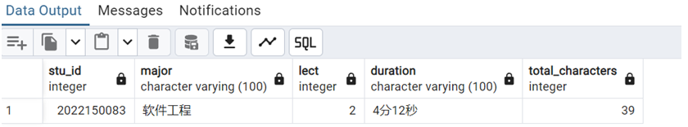
3.陈老师想要查询第2到第5课中从未提交过问卷的同学学号，SELECT stu_id
FROM students
WHERE stu_id NOT IN (
SELECT DISTINCT students.stu_id
FROM students
JOIN exercise ON students.stu_name = exercise.stu_name
WHERE exercise.lect BETWEEN 2 AND 5 AND exercise.submitTime IS NOT NULL
);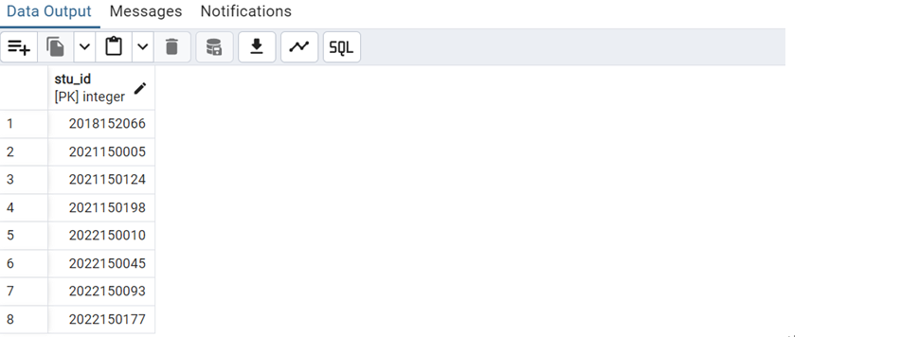
五.实验心得
经过本次sql实验，我对关系表的约束，sql复杂的单表查询以及多表连接查询掌握的更加熟练。

六.诚信承诺
本人郑重承诺在SQL实验的实施的过程中不发生任何不诚信现象，一切不诚信所导致的后果均由本人承担。

签名（手签，不得打印）：

指导教师批阅意见：

成绩评定：

指导教师签字：
年 月 日

备注：

